

CAVENDISH UNIVERSITY ZAMBIA

Project Proposal

Faculty of Information and Communications
Technology (ICT)

PROJECT TITLE: Developing a web app that creates a balanced diet for seven days using a randomization algorithm
NAME: David Chilanzi Sensenta
STUDENT NUMBER : 044-348
YEAR: 2023

Table of Contents
1.0 CHAPTER ONE: INTRODUCTION 4
1.0.0 Introduction 4
1.1 Background to the study 4
1.2 Problem statement 5
1.3 Purpose of the study 5
1.4 Objectives of study 5
1.4.1 General objective of study 5
1.4.2 Specific Objectives of study 5
1.5 Research Questions 6
1.6 Significance and justification of the study 7
1.8 Methodology 7
2.0 CHAPTER TWO: LITERATURE REVIEW 7
2.1 Introduction 7
2.2 Theoretical framework 8
2.3 Previous studies 9
2.3.1 FAO promoting health diet 9
2.3.2 Impact of a new web-based app (e-balance) in promoting a healthy lifestyle 9
2.4 Research gaps 10
2.5 Research variables arising from literature review 10
2.6 Conclusion 11
3.0 CHAPTER THREE: METHODOLOGY AND DESIGN 12
3.1 Introduction 12
3.2 Research Philosophy and Approach 12
3.3 Research design 13
3.3.1 Research Strategy 13
3.4 Conceptual model and Operationalization of research variables 14
3.5 Source of data 14
3.5.1 Primary data 15
3.5.2 Secondary data 15
3.6 Sampling methods 15
3.7 Sampling Techniques 15
3.8 Data Collection Techniques 16
3.9 Reliability / Validity and Ethical Considerations 17
3.10 Limitation of Study 17
REFEENCE 18

1.0 CHAPTER ONE: INTRODUCTION

1.0.0 Introduction
Zambia a developing country faces many challenges . One of these challenges is the poor eating habits of many Zambians, who often struggle to access or afford a varied and nutritious diet. Many Zambians consume foods processed foods and consume less fruits and vegetables, leading to a range of health problems I.e obesity, diabetes, and heart disease.
To address this problem, i proposes the development of a web application that uses a random generation algorithm to help users create a balanced diet for a week. The web app will take into account the user's food preferences, allergies and other restrictions as well as special conditions and generate a randomized diet plan that is nutritionally balanced and easy to follow. The goal of this web app is to improve the health and eating habits of Zambians by providing them with an easy ,accessible and convenient tool for following a healthy daily diet.
Technology has created many solutions to existing problems due to it being scalable, accessible and offers personalization. Web app which is a web technology can be accessed by a large number of people from any location with reliable internet connection, The random generation algorithm will allow the creation of personalized diet plans that are tailored to individual preferences and requirements as well as create random meals to make it engaging .

1.1 Background to the study
Zambia has put in place several steps to promote good healthy eating habits and ways ro address the issue of poor nutrition among its population, these are :
- The National Food and Nutrition Commission (NFNC) is responsible for coordinating and implementing nutrition policies and programs, with a focus on addressing the nutrition needs of vulnerable groups .
- The Scaling Up Nutrition (SUN) Movement is a global effort to improve nutrition outcomes, and Zambia is a member of this movement. Through its membership, Zambia has access to resources and technical assistance to support its nutrition programs and address specific issues such as diabetes and childhood obesity.
- The Ministry of Agriculture and Livestock encourages the production of nutritious food in the country, focusing on small scale farmers as well as promoting sustainable agriculture.
- Community-based nutrition programs run by NGOs and CBOs also focus on promoting healthy eating habits and addressing specific issues such as diabetes, through nutrition education and awareness-raising campaigns.

1.2 Problem statement
Despite all the efforts made by the government and other social organizations in promoting healthy eating habits in Zambia, the country continues to face significant challenges in this area, particularly diabetics and children. This research and development aims to investigate the causes of these challenges and propose a solution in the form of a web-based application that uses a random generation algorithm to help users create balanced diets for a week (7days).

1.3 Purpose of the study
To research and develop a web-based system that can help generate a balanced diet for Zambians, main focus is addressing the problem of poor nutrition in zambia .

1.4 Objectives of study

1.4.1 General objective of study
To develop a web application, code named "HealthyBites!," that helps users in Zambia generate a balanced diet for a week (7day) using a random generation algorithm, in order to address the problem of poor nutrition in the country, particularly among high-risk groups such as diabetics and children.

1.4.2 Specific Objectives of study
- To understand the current state of nutrition in Zambia and the challenges faced by the population in following a healthy eating regimen.
- To investigate the effectiveness of using technology as a solution to improve nutrition in Zambia.
- To design and develop a user-friendly web application that generates a personalized, balanced diet for users based on their dietary restrictions and preferences.
- To evaluate the effectiveness of the developed web application in promoting healthy eating habits and improving nutrition among users.
- To identify any limitations or areas for improvement in the web application and suggest recommendations for future work.

1.5 Research Questions
- What is the current state of nutrition in Zambia and what are the challenges people are facing in following a healthy diet?
- What are the existing solutions to improve nutrition in Zambia and what is their effectiveness?
- How can technology be used to improve nutrition in Zambia?
- Is the use of technology an effective solution to promoting healthy eating habits and improving nutrition in Zambia?
- How can a user-friendly web application be designed and developed to promote healthy eating habits and improve nutrition among Zambian people?
- What are the key features and functionalities of a successful web application for promoting healthy eating habits and improving nutrition in Zambia?
- How effective is the developed web application in promoting healthy eating habits and improving nutrition among users in Zambia?
- What is the user feedback and experience with the web application and what is the impact of the application on their nutrition and health status?
- What are the limitations or areas for improvement in the web application and what changes need to be made to make it more effective in promoting healthy eating habits and improving nutrition among Zambian people?
- What are the best practices and recommendations for future work to improve the web application and enhance its impact on promoting healthy eating habits and improving nutrition in Zambia?

1.6 Significance and justification of the study
The significance of this study lies in the potential impact it can have on improving the nutritional status of individuals in Zambia, Among high-risk groups (diabetics and children). With the increasing prevalence of diet-related health issues and the lack of accessible and user-friendly meal planning resources, there is a pressing need for a web-based meal planning application or Web app that utilizes advanced web technologies to make healthy eating more convenient and achievable. By carrying out this research and developing the web app, I aim to address this need and contribute to the well-being of the Zambian population.

1.8 Methodology
This will involve a combination of quantitative and qualitative methods in order to effectively gather and analyze data within a specific time frame.
- A literature review will be conducted to gather information on current meal planning applications and the nutritional status of individuals in Zambia, particularly among high-risk groups such as diabetics and children.
- A literature review will be conducted to gather information on current meal planning solutions developed countries have implemented.
- Interviews will be conducted with healthcare professionals particularly nutritionists in order to gather their views on the current state of nutrition in the country and the potential impact of a web-based meal planning web app.
- The prototype will developed and implemented .
The use of a combination of methods and a focus on both the user and healthcare professional perspectives will provide a comprehensive understanding of the problem and the potential impact of the proposed solution within the given time frame.

2.0 CHAPTER TWO: LITERATURE REVIEW

2.1 Introduction
The literature review is a crucial element of any research project, including this dissertation. It serves to offer an overview of the existing research in the field, pinpoint gaps in current knowledge, and create a foundation for the proposed research. By consolidating previous studies, analyzing the connections between variables, and assessing the necessity for further research, the literature review establishes a framework of knowledge and understanding that will inform the study's design and implementation. This section of the dissertation will delve into relevant literature, theories, and models related to the research topic.

2.2 Theoretical framework
According to Wakefield, Zgibor, & Kullgren (2016), promoting healthy eating through the integration of technology is the focus of the Health Information Technology (HIT) Model. This model comprises three primary components: the individual, the technology, and the environment. The individual component encompasses an individual's attitudes, beliefs, and motivation toward healthy eating. The technology component includes the features and functions of technology such as mobile apps or wearable devices. The environment component refers to the context in which the individual and technology interact, such as social support networks or access to healthy food options.
By taking into account all three components, the HIT Model offers a comprehensive perspective on how technology can support healthy eating. For example, the willingness of an individual to use technology that tracks food intake will be influenced by the ease of use and meaningful feedback provided by the technology. In addition, having access to healthy food options and support from others can help promote healthy eating habits.
The HIT Model can guide the design and implementation of health technology interventions aimed at promoting healthy eating. It emphasizes the importance of considering the individual's characteristics, technology features and functions, and environment to create effective and sustainable health technology interventions.
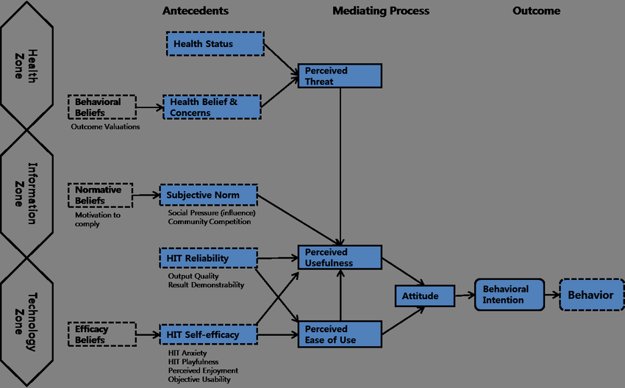

2.3 Previous studies

2.3.1 FAO promoting health diet
According to the Food and Agriculture Organization of the United Nations (FAO) (2021), Zambia has received several solutions to encourage healthy eating habits. The FAO has made dietary guidelines accessible through nutrition education and awareness-raising activities. The organization has collaborated with the Zambian government to integrate the guidelines into national policies and programs, as well as promote the development of food-based dietary guidelines and food composition databases.
Further, the FAO has partnered with various entities to strengthen the food systems in Zambia. which, includes promoting diverse and locally produced foods, making healthy foods more available and affordable, and creating food fortification programs to improve the nutrient content of staple foods.

2.3.2 Impact of a new web-based app (e-balance) in promoting a healthy lifestyle
In a randomized controlled trial conducted by Naimark et al., the effectiveness of a new web-based app called eBalance in promoting healthy lifestyles was evaluated. The study recruited participants from the community and compared them to a control group who received an introductory lecture on healthy lifestyles. The eBalance app was designed based on the current USDA and Israeli Ministry of Health recommendations and offered tools for monitoring diet and physical activity while encouraging healthy choices. The study's results indicated that the app had a positive impact on weight, physical activity, nutritional knowledge, and diet quality compared to the control group. Furthermore, a higher success score in maintaining a healthy lifestyle was linked to the frequency of app use. Although the study highlights the potential of the app in promoting healthy lifestyles, more definitive conclusions would require larger and longer duration studies.

2.4 Research gaps
- Limited research food habits and preferences of specific demographic or groups in Zambia, such as pregnant women, children, or elderly individuals.
- A lack of research on the effectiveness of nutrition education and awareness programs in promoting healthy eating habits in Zambia, particularly in rural or low-income communities.
- Limited research on the cultural and social factors that influence food choices and eating behaviours in Zambia, and how these factors can be addressed to promote healthier diets.
- Insufficient research on the potential impact of climate change on food security and the availability of nutritious foods in Zambia.
- Limited use of web technology to solve medical issues
- Limited research on the use of technology in promoting healthy eating habits and improving nutrition in Zambia, and how best to design and implement digital interventions that are accessible and effective for different populations.

2.5 Research variables arising from literature review
- Dietary intake: This variable could include the amount and types of foods consumed by individuals, as well as any nutritional deficiencies that may be present in the population.
- Cultural and social norms: These variables could influence what foods are considered acceptable or desirable to eat, and how meals are prepared and consumed.
- Availability and access to healthy foods: This variable could include the physical availability of healthy foods in Zambia, as well as the affordability and accessibility of these foods to different segments of the population.
- Technology adoption and usage: This variable could include the extent to which technology is currently being used in Zambia to support healthy eating, as well as any barriers to adoption or usage.
- Health outcomes: This variable could include measures of health status or disease prevalence that are related to diet, such as rates of obesity, malnutrition, or chronic diseases.

2.6 Conclusion
The Health Information Technology (HIT) Model provides a comprehensive approach to using technology to support healthy eating by considering individual characteristics, technology features, and the environment which is clearly a good model to use for combining technology and health.
They are many schemes put in place to try to promote good eating habits, on the local front The FAO has already implemented various solutions to promote healthy eating in Zambia, such as making dietary guidelines accessible and strengthening the food systems. and on the international front other studies like the study by Naimark et al. showed the potential of a web-based app in promoting healthy lifestyles. However, More research is needed to understand specific groups' dietary habits, the effectiveness of nutrition education, cultural and social factors influencing food choices, climate change's impact on food security as well of using technology to promote healthy eating.
In general, the literature review forms the basis of knowledge that will guide the proposed research's design and implementation. The study's results will help address the identified research gaps and contribute to the existing literature on promoting healthy eating in Zambia. Policymakers, public health practitioners, and other stakeholders working towards promoting healthy eating in Zambia will find the research findings valuable.
.

3.0 CHAPTER THREE: METHODOLOGY AND DESIGN

3.1 Introduction
In this chapter, I outline the methodology and design picked to address the research questions and achieve the research objectives. it presents a detailed account of the research approach, design, data collection methods, data analysis techniques, and ethical considerations. The thinking behind the chosen methodology and design is elaborated and explained in detail, as well as the strengths and limitations of the approach. The chapter will be organized into several sections to provide a clear and comprehensive overview of the study's methodology and design.

3.2 Research Philosophy and Approach
the research will follow the normal flow of software development by implementing the Software Development Life Cycle (SDLC) model, which involves several stages, starting with the
• Planning stage: In this stage, we establish the goals and objectives of our research, and identify the scope of our study. We review existing literature on particular topics, consult with nutrition experts, and use Google questionnaires to gather relevant data.
• Analysis stage: we will gather and analyze data related to the nutritional content and quality of food options available to consumers. We will use a variety of data sources, such as nutritional databases and Google questionnaires, in order to help us gain a better understanding of the current eating habits of Zambians.
• Design stage will involve the development of our research framework and methodology, where we will carefully design our study to ensure it is both valid and reliable. We will use appropriate sampling techniques and statistical analysis to ensure the accuracy of our findings.
• Development stage: where we will begin collecting and analyzing data. We will use Google questionnaires to gain insight into consumer attitudes and behaviors related to healthy eating.
• Testing stage: will involve the validation of our research findings and the identification of any potential biases or limitations in our study. We will conduct thorough data analysis to ensure the accuracy and validity of our findings and address any potential issues that may arise.
Deployment stage, we will disseminate our research findings to key stakeholders, such as policymakers, healthcare providers, and nutritionists. We will provide recommendations for improving healthy eating habits, and promote the adoption of evidence-based interventions to improve the nutritional status of consumers.
Overall, our research philosophy and approach are grounded in the SDLC model, which provides a structured and systematic approach to the study of healthy eating habits, even when faced with time constraints.

3.3 Research design
During the research, there are two primary methods or research design types: exploratory and conclusive research. The former seeks to identify and explore potential problems or situations to gain insight and understanding, while the latter aims to test specific hypotheses and examine relationships. As we dive into the topic of healthy eating and eating habit by the Zambian people in relation to healthy eating for the Healthy Bite web application, it's critical to note that the research design falls under the category of descriptive research, which is used to describe the characteristics of population, organizations, or markets. A descriptive research design is the most suitable approach for the Healthy Bite app because its the method that employs quantitative data to measure the factors influencing healthy eating behavior.

3.3.1 Research Strategy
Will begin with a thorough literature review to help formulate research questions .that will be the basis of the research, from the response or feedback that will be obtained from the questionnaire, responses with similar attributes will be put together to form personas, these will be used in order to gain a better understanding of the problem at hand. By using this problems will be identified and a user-centered approach to solving the problems will be carried out, the research will focus on solving the personas problems, According to E.Navoseltseva (2018) “User-centered design (UCD) is an iterative design process in which designers and other stakeholders focus on the users and their needs in each phase of the design process. UCD calls for involving users throughout the design process via a variety of research and design techniques so as to create highly usable and accessible products for them.” therefore this approach has been shown to be effective in designing solutions to problems. Finally, the data collected from the personas will be analyzed through the use of frequency tables, and conclusions and recommendations will be drawn based on the findings.

3.4 Conceptual model and Operationalization of research variables

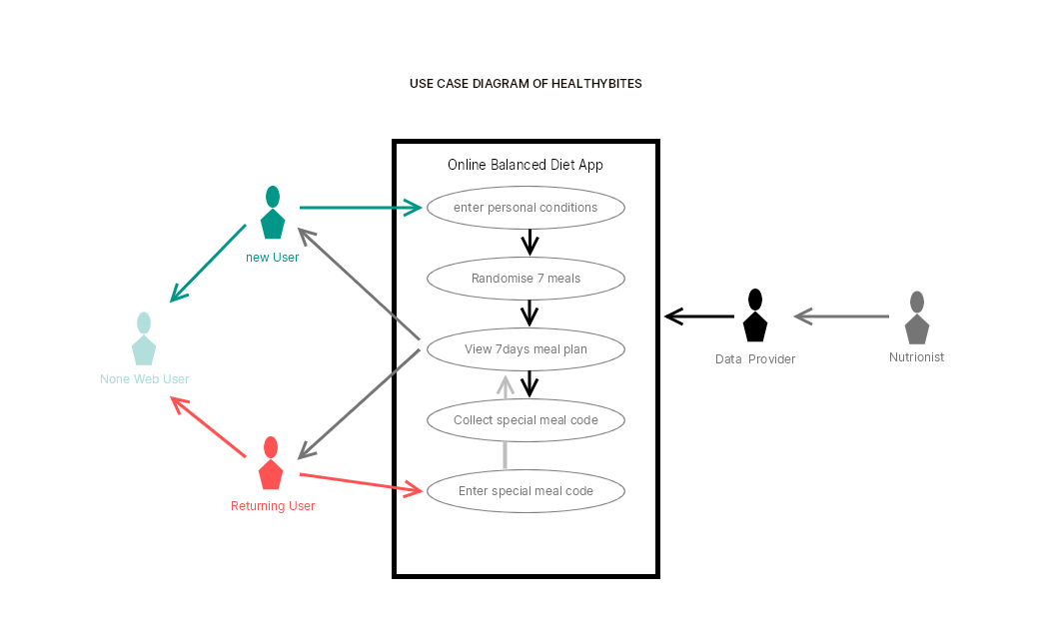
This web app will be an online application hosted on ,this is so that everyone can access it online without having to install it onto their devices meaning everyone has the access to it no matter how old the device
they are using to access the web app it has no hardware requirements only access to the internet.
Further research shows that not everyone in Zambia has good access to internet however the proposed system will not require account login so that even health care centers can create balanced meals for individuals on the fly without stressing to much on registration.
Returning users ,shows that they want to continue on passed saved details because this system has no registration and no need for data base to store user information therefore a model that works around this will be developed since tool is intend to be a guide that helps people plan health meals.

3.5 Source of data
The source of data for the study has been a major concern, therefor both primary and secondary modes of data collection were utilized to overcome the potential weaknesses of intrinsic biases and problems that may arise from a single method and theory of studies ,research employed methodological triangulation, which involved reviewing interviews, observations, and questionnaires.

3.5.1 Primary data
Majority of the data collected was from Questionnaire issued to the local nutritionists at a small local clinic and a big hospital. The majority of the information from these Questionnaire stated that, eating healthy in a Zambian house hold is a luxury because most of the common Zambian people leave below the poverty line therefore they eat what their pockets can afford to eat and do not know that even local cheap food can be structured in a balanced format. One nutritionist also stated that most of the people who access his services at the hospital are those who are pregnant or are are in critical condition if a nutritionist guide is not found which should not be the case.the observation from all this is that most Zambians do not really focus on healthy eating .

3.5.2 Secondary data
The secondary data was from analyzing the old system and Literature available from Zambian nutrition books available in Zambia The Internet's e-books and blogs were helpful in the collection of information in a quest to develop the web based online web application system. Interviews also assisted in collecting the secondary data as the number of selected hospital patients (pregnant women, diabetics and children parents) where interviewed to obtain information on the ways that they get balanced meals and how they pick balanced schedules .

3.6 Sampling methods
It is important to structure ways to collect information because it helps ensure that the data collected is relevant, accurate, and reliable.
- Questionnaires
- Interviews
- Observation
- Analysis of old System

3.7 Sampling Techniques
In this research two sampling techniques where used
- Stratified Sampling: involves dividing the population into subgroups (or strata) and selecting individuals from each subgroup in proportion to their representation in the population.
- Snowball Sampling: involves selecting individuals who can refer or introduce other individuals who fit the criteria for the study.

3.8 Data Collection Techniques
Three techniques were use to collect information from nutrition professional and general public. These includes
- Observation
- Interviews
- Questionnaires
Observation: the observation on how Zambians and eating health is that they tend to avoid it and only pay attention to health eating when instructed by the doctors when their health worsens due to bad eating habits and some assume its expensive to eat right
Interviews: A selected few individuals (diabetics ,pregnant women and parents ) from the hospital where interviewed to obtain information on ways they get guides on good balanced diet and how easy they find these guides. Most of them stated that the hospital nutritionist guides them on what to eat and most of the time its a rushed process ,they also noted that they would want an easy guide that is easily followed than having to have the same meals issued and standing in line for detailed plan.
Questionnaires: Basically, questionnaires where issued to a few nutritionists that provided the views of the nutrition on how nutrition is being viewed among est the local public and The majority stated that, information on nutrition is easy to find but the foods that are recommended in these nutrition guides seem tailored for the west and locals tend to assume its expensive to eat right since most leave bellow the poverty line.

3.9 Reliability / Validity and Ethical Considerations

3.10 Limitation of Study
1. Data collection limitations: The study faced challenges in accurately collecting data on the dietary habits and nutritional status of individuals in Zambia, which can affect the validity of the findings.
2. Cultural and social factors: The cultural and social norms such as income, food availability, etc surrounding food and eating habits in Zambia impact the effectiveness of the web application in promoting healthy eating.
3. Technology adoption: The study also faced challenges related to technology adoption as most of Zambians areas are not familiar with using web applications or do not have access to the technology needed to use the application especially rural-based area individuals.
4. Limited sample size: The study has a limited sample size because the time for developing reliable samples is extremely limited, which may have affected the generalization of the results.
5. Data privacy and security: The study must consider data privacy and security concerns, as individuals may not be comfortable sharing personal information such as dietary restrictions.
6. Resource constraints: The study may face budget and resource constraints, which could impact the quality and accuracy of the results

REFEENCE
- Cochran, W. G. (1991). Sampling Techniques, 3rd Edition. New York: John Wiley & Sons.
- Food and Agriculture Organization of the United Nations (FAO). (2021). Food and Dietary Guidelines – Zambia. Retrieved from https://www.fao.org/nutrition/education/food-dietary-guidelines/regions/countries/zambia/en/
- Naimark, J. S., Madar, Z., & Shahar, D. R. (2023). The Impact of a Web-Based App (eBalance) in Promoting Healthy Lifestyles: Randomized Controlled Trial. Journal of Medical Internet Research, [Article]. https://doi.org/10.2196/jmir.9999.
- Wakefield, B., Zgibor, J. C., & Kullgren, J. (2016). Health information technology and behavior change: a review of the literature. American Journal of Preventive Medicine, 50(3), 283-294.
- UNICEF. (2021). Zambia Scaling Up Nutrition Newsletter July 2021. Retrieved from https://www.unicef.org/zambia/media/2406/file/Zambia-scaling-up-nutrition-newsletter-july-2021.pdf
- National Food and Nutrition Commission. (n.d.). About Us. Retrieved January 25, 2023, from https://www.nfnc.org.zm/about-us/
- Simplilearn. (n.d.). What is SDLC (Software Development Life Cycle)? Simplilearn.com. Retrieved January 25, 2023, from https://www.simplilearn.com/tutorials/programming-tutorial/what-is-sdlc
- Grad Coach. (n.d.). What is a Literature Review? Retrieved from https://gradcoach.com/what-is-a-literature-review/
- Novoseltseva, E. (2018). User-Centered Design: An Introduction. Usability Geek. Retrieved from https://usabilitygeek.com/user-centered-design-introduction/

